Assignment 1: Create a visualization showing Profitability By State
Data Source: Data of hypothetical transactions of a sample super store in US for the year 2015
File: Excel file named “P1-SuperStoreUS-2015.xlsx”
Tableau Public URL: Profitability By State | Tableau Public
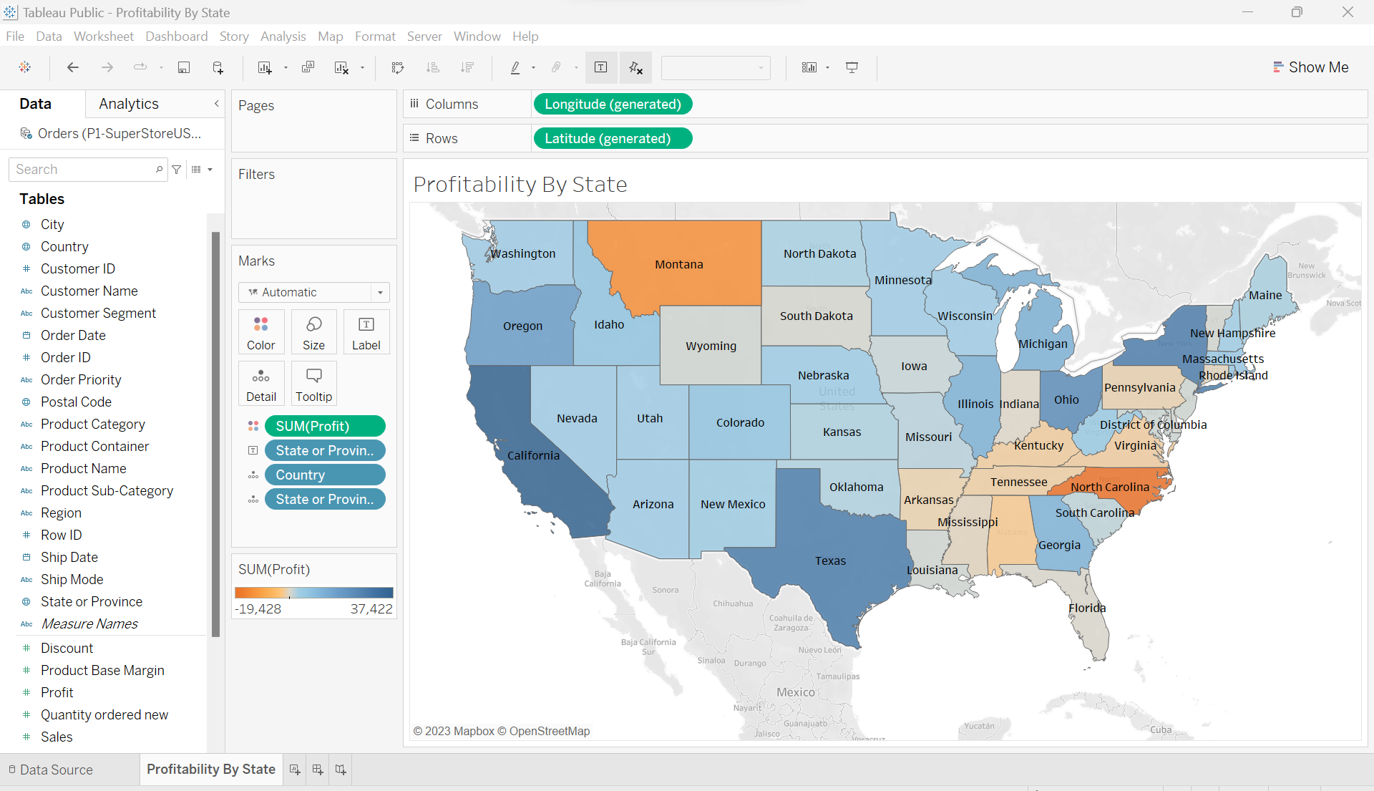
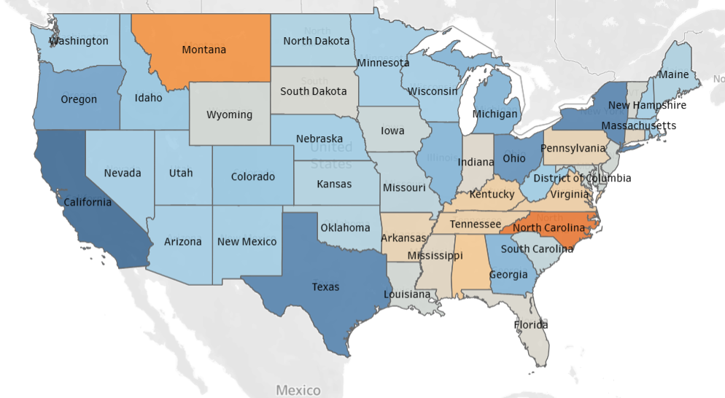
Inferences:-
- North Carolina has incurred highest losses followed by Montana. California has reported highest profits, followed by Texas
- Majority of the States belonging to eastern part of the country reported loss.
- Majority of the States belonging to western part of the country reported profit.

